ASSIGNMENT 4.3

HTNO:2403A51319

TASK 1:

USING GOOGLE COLAB:

**Task Description#1**

* Zero-shot: Prompt AI to write a function that checks whether a given year is a leap year.

**Expected Output#1**

* AI-generated function with no examples provided
* PROMPT:

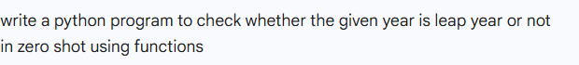

CODE:

OUTPUT:

CODE EXPLANATION:

• The code defines a function called is_leap that checks if a year is a leap year.

• A leap year happens every 4 years, **but** not every year that is divisible by 100.

• However, if a year **is divisible by 400**, it **is** still a leap year.

• The function uses this rule to return True (if it is a leap year) or False.

• A list of three years is created: 2024, 1900, and 2000.

• The code goes through each of these years one by one using a loop.

• It checks if the current year is a leap year by calling the is_leap function.

• If the function returns True, it prints that the year **is** a leap year.

• If it returns False, it prints that the year **is not** a leap year.

• This helps us understand which years are leap years based on simple rules.

**Task Description#2**

* One-shot: Give one input-output example to guide AI in writing a function that converts centimeters to inches.

**Expected Output#2**

* Function with correct conversion logic

PROMPT:



CODE:

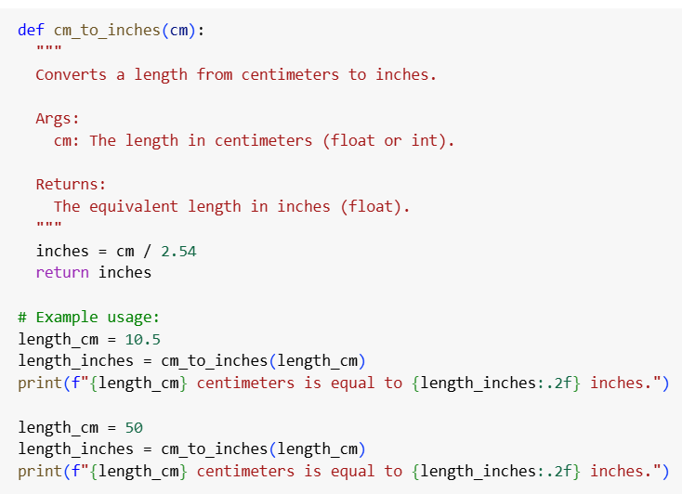

CODE EXPLANATION:

• **Purpose**:  
The code is written to convert a length from **centimeters to inches** using a function.

• **Function Use**:  
A function is created to do the conversion, so it can be reused easily for any value.

• **How It Works**:  
Inside the function, the given value in centimeters is divided by **2.54**, because **1 inch = 2.54 centimeters**. This gives the equivalent value in inches.

• **Return Value**:  
After doing the conversion, the function gives back (returns) the result in inches.

• **Examples**:  
The code then shows two examples:

* First, it converts **10.5 centimeters** into inches.
* Then, it converts **50 centimeters** into inches.

• **Output Format**:  
The results are printed in a user-friendly way, showing the original value in centimeters and the converted value in inches, rounded to two decimal places.

• **Result**:  
When the code runs, it clearly tells you how many inches each centimeter value equals.

OUTPUT:

**Task Description#3**

* Few-shot: Provide 2–3 examples to generate a function that formats full names as “Last, First”.

**Expected Output#3**

* Well-structured function respecting the examples

PROMPT:

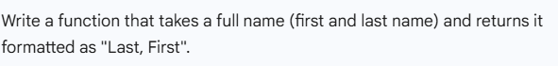

CODE:

CODE EXPLANATION:

• **Function Definition**  
A function called format_name is created. It takes a single input: full_name, which is expected to be a string like "John Doe".

• **Splitting the Name**  
Inside the function, it uses .split() to break the full name into parts using spaces.

* For "John Doe" → it becomes ["John", "Doe"]
* For "Peter Pan" → ["Peter", "Pan"]

• **Handling the Parts**

* If the name has **two or more parts**, the code:
  + Takes the **last word** as the **last name**
  + Joins all the previous words (usually the first name) as the **first part**
  + Returns a string formatted as "Last, First"

OUTPUT:

**Task Description#4**

* Compare zero-shot and few-shot prompts for writing a function that counts the number of vowels in a string.

**Expected Output#4**

* Functional output and comparative reflection

PROMPT:



CODE:

CODE EXPLANATION:

1. **Takes a sentence or word as input**  
   You give the program a string of text (like "Hello World" or "Programming is fun").
2. **Looks at each letter one by one**  
   It goes through the text, checking each character in the string.
3. **Checks if the character is a vowel**  
   For every character, it asks:  
   *"Is this an A, E, I, O, or U (upper or lowercase)?"*
4. **Keeps track of how many vowels it finds**  
   If the character is a vowel, it adds 1 to a running total.
5. **Gives you the total number of vowels**  
   After checking the whole string, it tells you how many vowels it found.

OUTPUT:

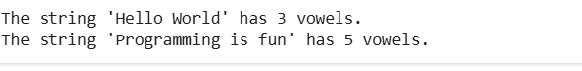

**Task Description#5**

* Use few-shot prompting to generate a function that reads a .txt file and returns the number of lines.

**Expected Output#5**

* Working file-processing function with AI-guided logic

PROMPT:

CODE:

CODE EXPLANATION:

• **nput**  
The function receives the name (or path) of the file to read.

• **Opening the File Safely**  
It tries to open the file in read mode.

* If the file doesn’t exist, it catches this problem and returns -1.

• **Counting Lines Efficiently**  
If the file opens successfully, it goes through the file **line by line**, counting each line without loading the entire file into memory.

• **Returning the Result**  
After counting, it returns the number of lines found.

• **Error Message**  
If the file is missing, it also prints a helpful error message to let you know.

OUTPUT: